

King Abdul Aziz University

Faculty of Computing and Information Systems

Information System Department

(Fall 2018) –First Term 2018

**_____________________________________________________________**

**Assignment 1**

**Social Network Analysis**

**Munera AlRajhi 1505590**

**Sarah AlZharani 1505091**

**Rawan AlGhamdi 1511889**

**Introduction:**

Network analysis is an important method for identifying and exploring relations between a group of institutions, individuals, or objects. Rather than simply exposing how a small number of variables react to each other, this form of analysis can allow a researcher to examine an entire community of data points showing power structures (i.e. groupings and hierarchy), information or resource flow (i.e. directionality), and other network characteristics such as density and diameter. This report utilizes network analysis by focusing on the visualization of a social network using Gephi.

The data set used for this study’s is Political blogs a directed network of hyperlinks between weblogs on US politics contain 105 nodes and 441 edges that represent the relationship between them**.**

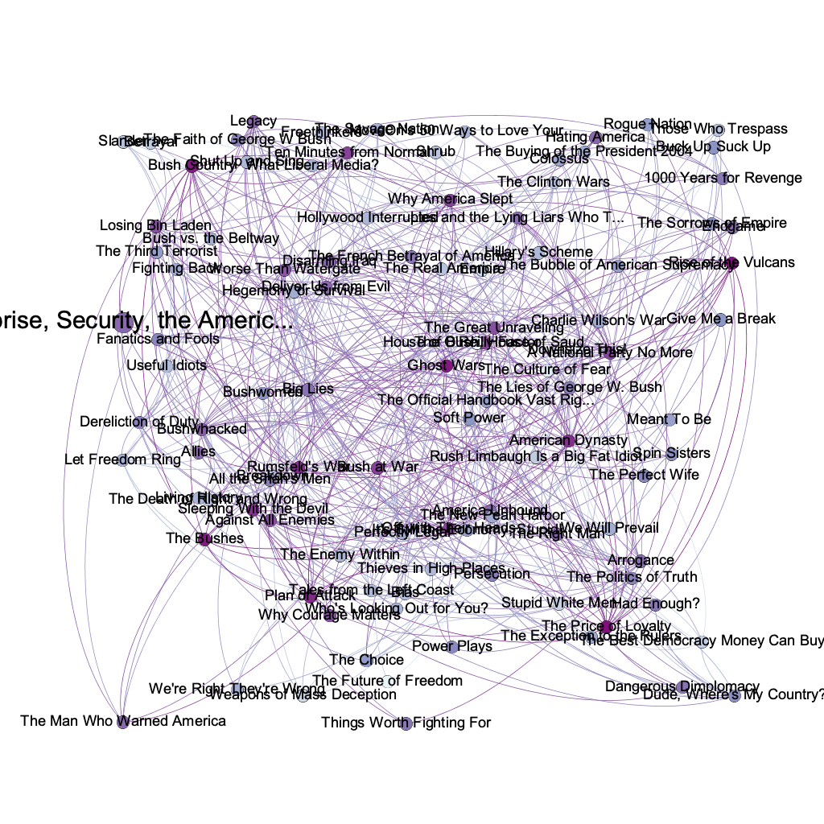

Dataset Network Analysis Overview.

**Statics and Methods:**

* **Betweenness Centrality:**

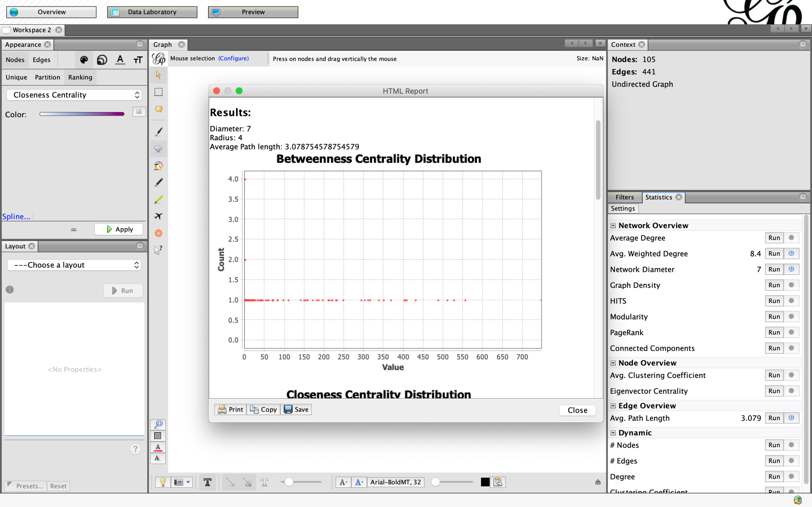

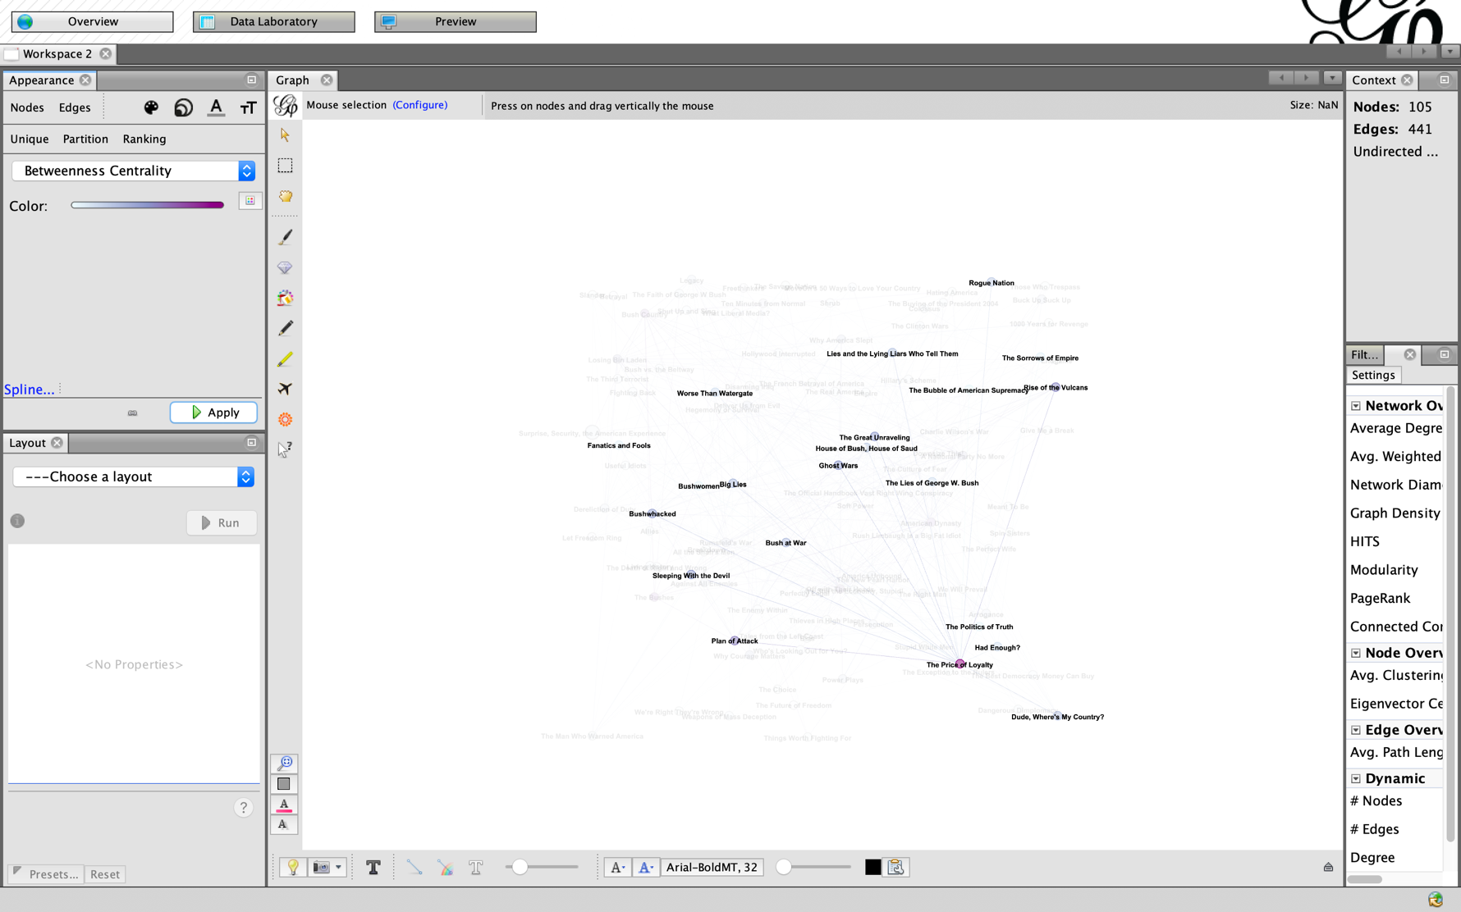

**A National Party No More Node has the major influence among the dataset.**

* **Closeness Centrality:**

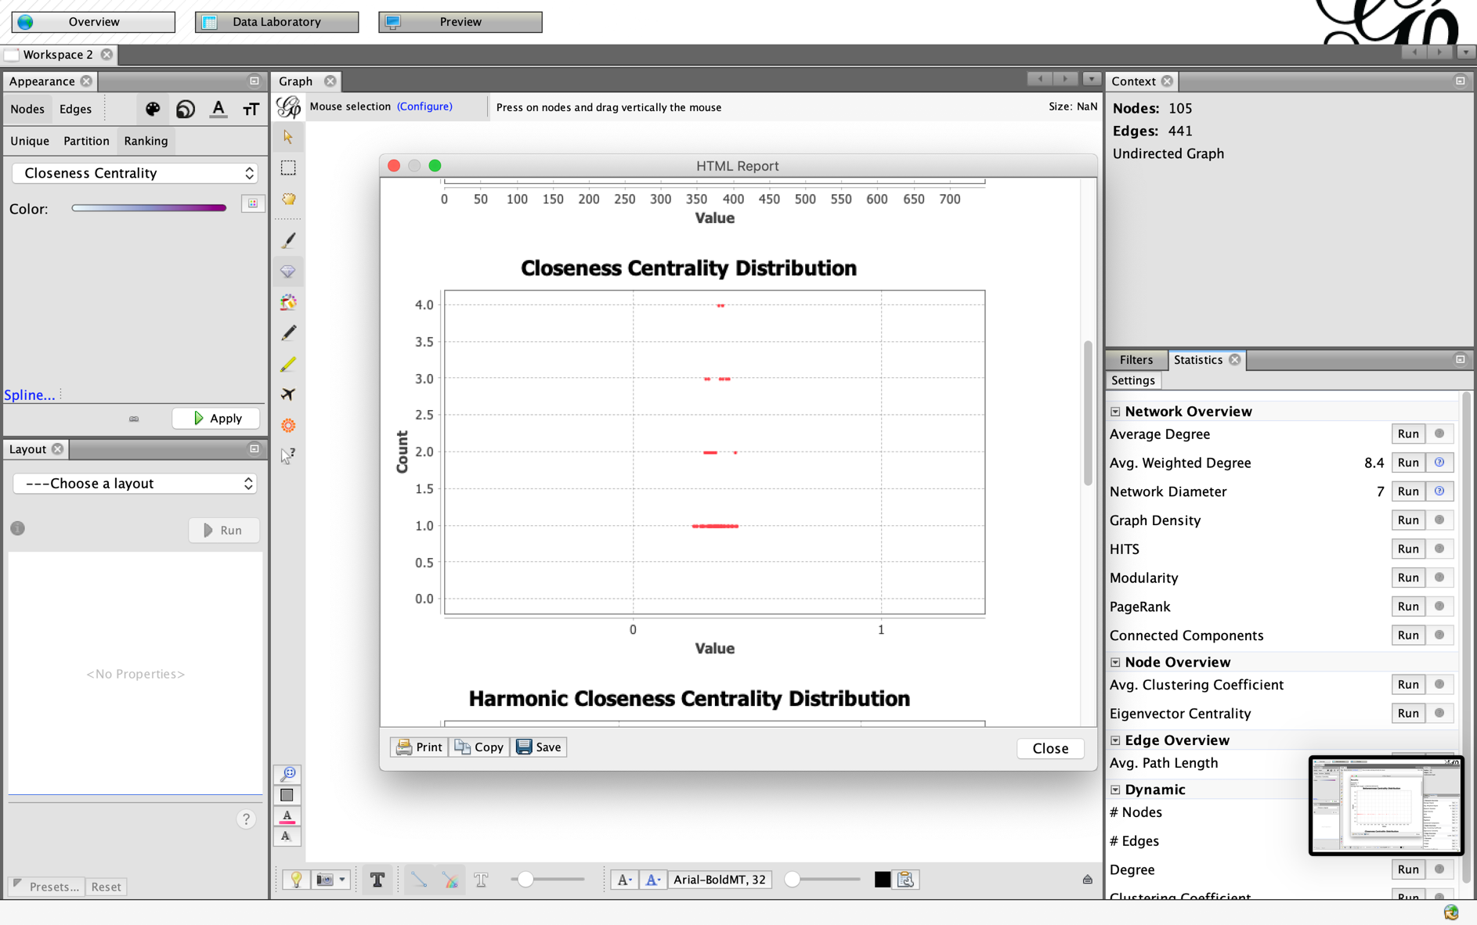

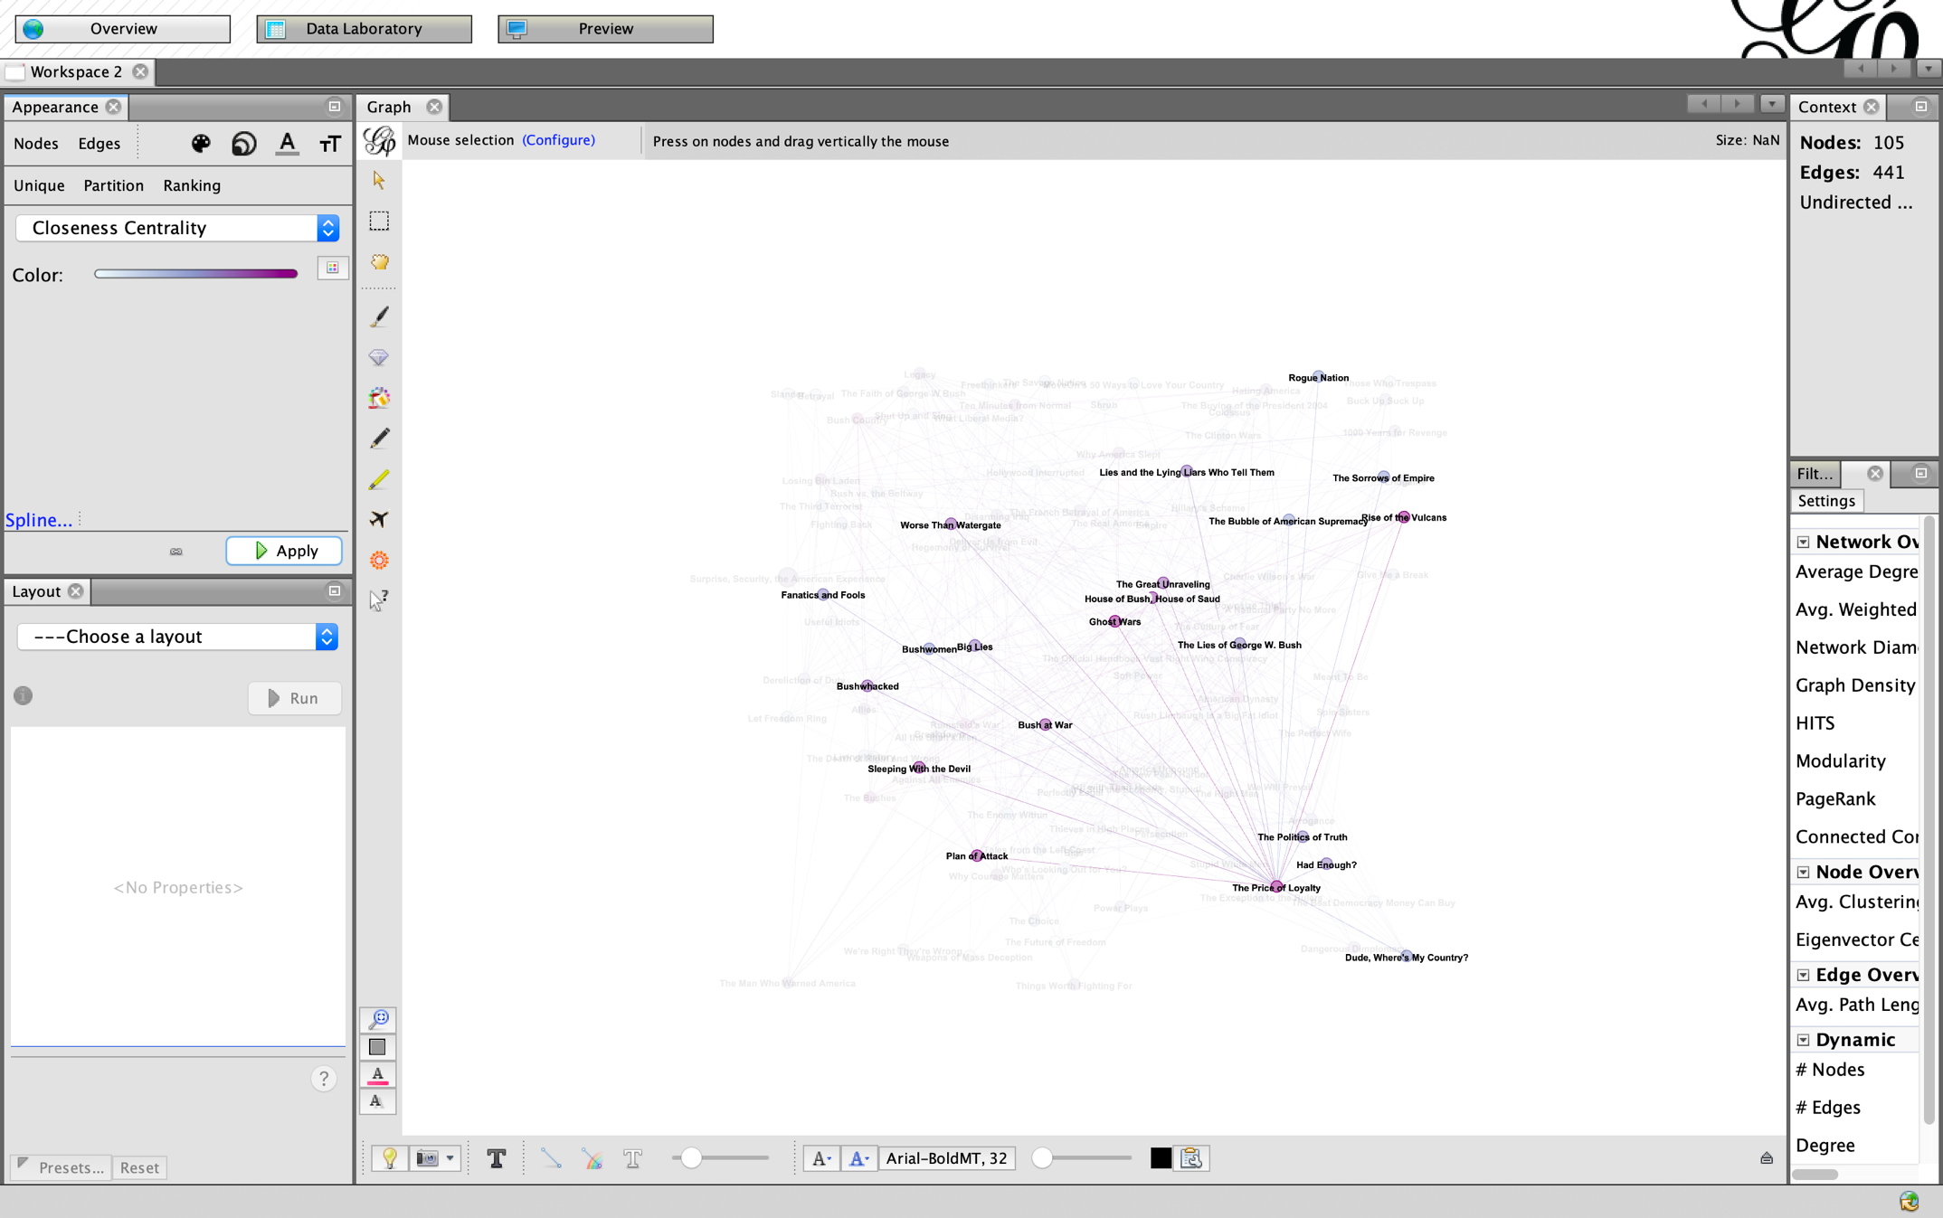

The Price of Loyalty Node has the highest closeness among dataset.

* **Degree of cancerization:**

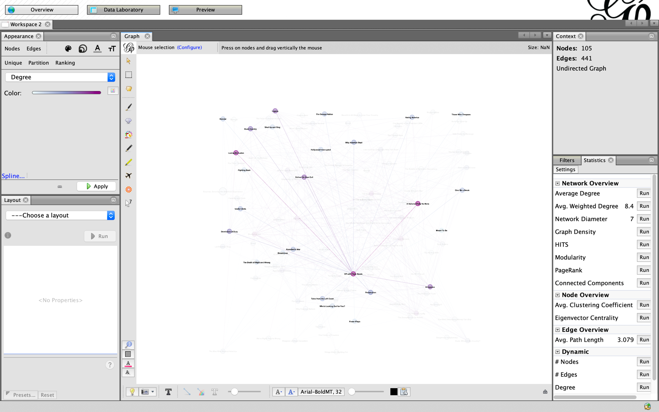

Off with Their Heads Blog Node has a 24 different degree of centrality ignoring directions.

**Conclusion:**

Data of social networks contains a huge information, as for that a person must know what to search for in these data. To extract the knowledge that will be benefited from. We provided a simple demonstration of a social network for politic books and did some statics and methods for it.